데이터베이스 LAB Database 문제 풀이

2017112085 이유경

1.

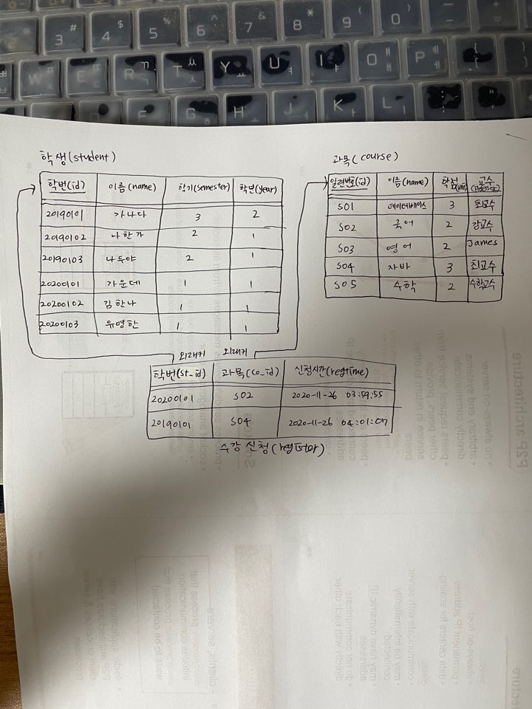

2.

create database dgu;

3.

create table student(id char(8), name varchar(40), semester int, primary key(id));

create table course(id char(8), name varchar(40), unit int, professor varchar(20), primary key(id));

create table register(st_id char(8), co_id char(8), regtime datetime);

4.

insert into student values('20190101', '가나다', 3), ('20190102', '나한가', 2), ('20190103', '나두야', 2), ('20200101', '가운데', 1), ('20200102', '김한나', 1), ('20200103', '유명한', 1);

5.

insert into course values('S01', '데이터베이스', 3, '최교수'), ('S02', '국어', 2, '강교수'), ('S03', '영어', 2, 'James'), ('S04', '자바', 3, '최교수'), ('S05', '수학', 2, '수학교수');

6.

insert into register (select st.id, co.id, now() from student st, course co where st.name = '김한나' and co.name = '데이터베이스');

7.

select * from register;

8.

insert into register (select st.id, co.id, now() from student st, course co where st.name=’김한나’ and (co.name=’국어’ or co.name=’영어’));

9.

select * from register;

10.

insert into register values('20200101', 'S02', NOW()), ('20190101', 'S04', NOW()));

11.

select co.name as 교과목, co.unit as 학점, co.professor as 교수 from student st, register re, course co where st.name='김한나' and st.id=re.st_id and co.id=re.co_id order by co.name;

12.

select st.name as "이름", count(*) as "과목수", sum(co.unit) as "총학점수" from student st, register re, course co where st.id = re.st_id and co.id = re.co_id group by st.name;

13.

delete from register where st_id = (select id from student where name="김한나") and co_id = (select id from course where name="국어");

14.

update student set semester = semester+1 where id in (select distinct st_id from register);

15.

delete from course where id not in (select co_id from register group by co_id having count(*) >= 5);

delete from register where co_id not in (select co_id from register group by co_id having count(*) >= 5);